Name: Cameron Windsor Fox

Major: Computer Science Major

Chosen Mechanism: Program Coding with Video-Game Development

Introduction & Technical Definition of Chosen Mechanism:

Program Coding with Video-Game Development, is the use of coding skills used for creating virtual, functional, and entertaining content in video-games for others. The different parts that help make up the program code for video-game development is somewhat different depending on the type and style of game being created, but also similar in the core components used for development. The similarities for program coding in video-games is they all share the same or similar basic starting function, or sections of code that make up the beginning building blocks of the whole program. After that the games branch off into whatever design the developers want to use. These basic coding functions can be classified as; The Main Method for setting up the beginning components. Action Trigger/Event Methods for when doing a certain action will trigger a type of event. As well as Character Bio Methods for storing information. In addition, there is also a use of using multiple classes, the need to keep your program code cleaner and organized.

Main Method

The main Method is always an important necessity for programing code in addition to program coding with video-game development. This methods use is for keeping track of the other method when they are called as well as the order when they are called and executed. There is not set length of how big this method needs to be or what variables it must contain, it all is depended on the coder him/her-self. This method is very important because this is the main backbone of the whole coding program that is being developed. As shown in (Figure 1). Without this method, the entire program would not be able to run properly or the game code would simply crash. This section of code is the basis for every game the is being code programmed and developed by any videogame company. Following the construction of the Main method in the program of coding a game, there is the use of action trigger method and event handler methods.

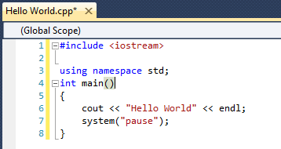

Action Trigger/Event Method

Action Trigger and Event Handler Methods are also a main importance with video-game coding. These methods are used for activating special events or section of the game for if the player walking into an open room triggers an ambush action event, where the player is trapped by the enemy or by their own choice. Another example would be with setting up event handlers for when the game is going to switch from game play to cutscenes. This is the main purpose of these methods and how they function, it’s a method with not a lot of additional code needed but also plays a good role for program coding video-games. An example of this can be seen in (Figure 2). Another part of a game that a player would like to see is having a Bio for all the information about the character they are playing as, this is where the Character Bio Method comes in handy.

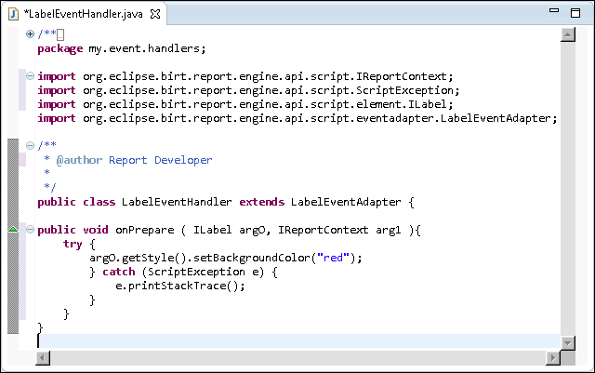

Character Bio Method

The Character Bio would be a simple method that is used for displaying the main information and details about the character of the players choosing like a biography. This method use would be the have a display showing the player information about the character such as; character background, current armor and weapons equipped, as well as status effects if the player is hurt or injured during the game. Aside from that main use, the character bio doesn’t have much more to show for the player unless there are additional classes that were coded and programmed into the game that would allow additional uses for this method or other methods created for the game. An idea of what this method can look like is shown here in (Figure 3).

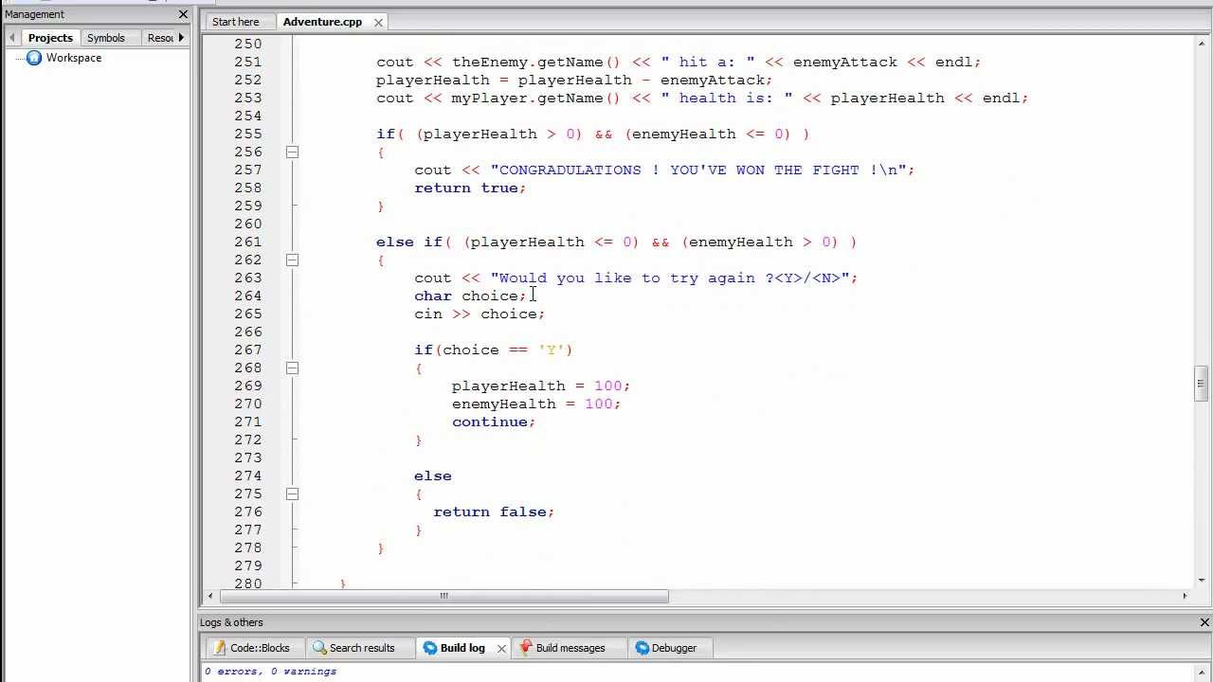

Additional Classes

Another main help with video-game program coding is the aid of additional classes, additional classes are useful with code organization and to keep some methods from overlapping and creating memory leaks or other types of errors within the code. This is also useful, by using additional classes for specific attributes or creating methods for a specific aspect of the game located in one class and then using another class for a different aspect that is necessary for the game development. As shown in (Figure 4). Of course, though even with the additional class created, they will be useless and not usable without the main method class to call and be able to locate where these class files are so the code can be recognized and implemented.

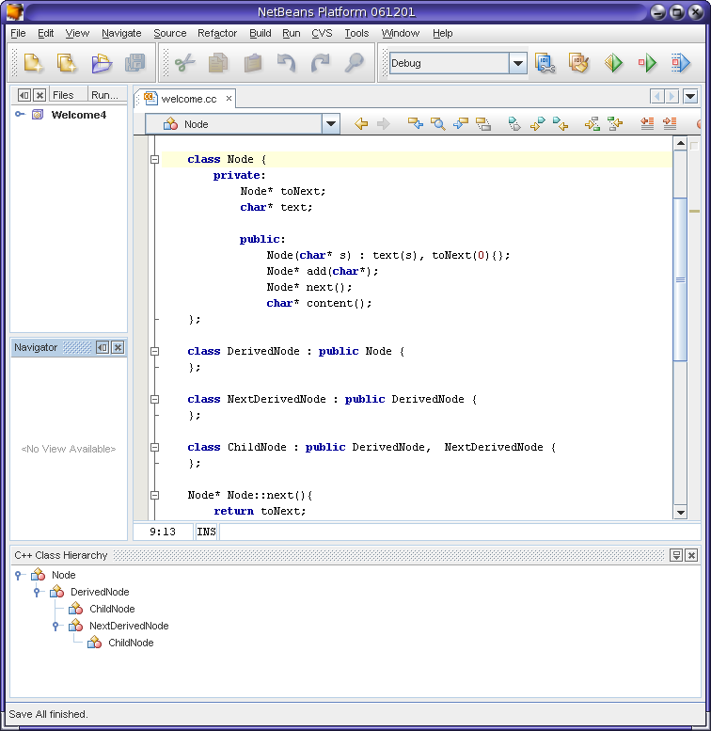

Conclusion:

Program Coding in Video-Game Development is a main essential component used for creating and building any video-game. With all the different coding methods that are needed for creating a video-game, it takes a lot of hard work and dedication. But even with all that without the use of the Main Method function or Action Trigger/Event Handler Methods, or the Character Bio method creation, as well as the use of additional classes program coding is what helps allow a video-game to function and allow the developers to create a virtual world and environment for the player to explore, to learn all about and to interact with other characters you can find in the game. With all the different methods and code used in developing video-games it shows just how important coding is and how important developers try to get everything right so the game will run correctly and fluently.

References:

Figure 1: <http://byu.danrolsenjr.org/Cpp/Images/HelloWorld-Cpp.PNG>

Figure 2: <http://help.eclipse.org/kepler/topic/org.eclipse.birt.doc/birt/images/MyLabelClass2.png>

Figure 3: <https://i.ytimg.com/vi/IEh4ZlUP9vQ/maxresdefault.jpg>

Figure 4: <http://cnd.netbeans.org/docs/hierarchy-tutorial/api.jpg>